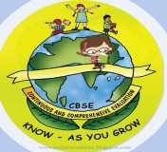
GREENWOOD PUBLIC SCHOOL, D.D. NAGAR
HOLIDAY HOMEWORK SESSION – 2020-21
CLASS – X

SUBJECT - COMPUTER
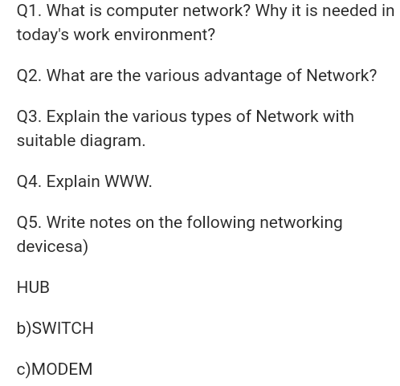SUBJECT – S.ST
HISTORY (Outline Political Map of India)
Map-1
Chapter - 3 Nationalism in India – (1918 – 1930) for Locating and Labelling / Identification
1. Indian National Congress Sessions:
a. Calcutta (Sep. 1920)
b. Nagpur (Dec. 1920)
c. Madras (1927)
Map-2
2. Important Centres of Indian National Movement
a. Champaran (Bihar) - Movement of Indigo Planters
b. Kheda (Gujarat) - Peasant Satyagrah
c. Ahmedabad (Gujarat) - Cotton Mill Workers Satyagraha
d. Amritsar (Punjab) - Jallianwala Bagh Incident
e. Chauri Chaura (U.P.) - Calling off the Non-Cooperation Movement
f. Dandi (Gujarat) - Civil Disobedience Movement

GEOGRAPHY (Outline Political Map of India)
Chapter 1: Resources and Development (Identification only)
Map-3
- Major soil Types
Chapter 3: Water Resources (Locating and Labelling)
Map-4
Dams:
a. Salal b. Bhakra Nangal c. Tehri d. Rana Pratap Sagar
e. Sardar Sarovar f. Hirakud g. Nagarjuna Sagar h. Tungabhadra
Note: The theoretical aspect of chapter ‘Water Resources’ to be assessed in the Periodic Tests only and will not be evaluated in Board Examination. However, the map items of this chapter as listed above will be evaluated in Board Examination.

Chapter 4: Agriculture (Identification only)
Map-5
Major areas of Rice
Map-6
Major areas of Wheat
Map-7
Largest / Major producer states of Sugarcane
Map-8
Largest / Major producer states of Tea
Map-9
Largest / Major producer states of Coffee
Map-10
Largest / Major producer states of Rubber
Map-11
Largest / Major producer states of Cotton
Map-12
Largest / Major producer states of Jute
Map-13
Chapter 5: Minerals and Energy Resources
Minerals (Identification only)
Map-14
Iron Ore mines
a. Mayurbhanj b. Durg c. Bailadila d. Bellary e. Kudremukh
Map-15
Coal Mines
a. Raniganj b. Bokaro c.Talcher d. Neyveli
Map-16
Oil Fields
a. Digboi b.Naharkatia c. Mumbai High
d. Bassien e. Kalol f. Ankaleshwar
Map-17
Power Plants
(Locating and Labeling only)
Thermal
a. Namrup b. Singrauli c. Ramagundam
Map-18
Nuclear
a. Narora b. Kakrapara c. Tarapur d. Kalpakkam
Chapter 6: Manufacturing Industries (Locating and Labeling Only)
Map-19
Cotton Textile Industries:
a. Mumbai b. Indore c. Surat d. Kanpur e. Coimbatore
Map-20
Iron and Steel Plants:
a. Durgapur b. Bokaro c. Jamshedpur d. Bhilai e. Vijaynagar f. Salem
Map-21
Software Technology Parks:
a. Noida b. Gandhinagar c. Mumbai d. Pune e. Hyderabad f. Bengaluru
g. Chennai h. Thiruvananthapuram

Chapter 7: Lifelines of National Economy
Map-22
Major Ports: (Locating and Labelling)
a. Kandla b. Mumbai c. Marmagao d. New Mangalore e. Kochi
f. Tuticorin g. Chennai h. Vishakhapatnam i. Paradip j. Haldia
Map-23
International Airports:
a. Amritsar (Raja Sansi) b. Delhi (Indira Gandhi International)
c. Mumbai (Chhatrapati Shivaji) d. Chennai (Meenam Bakkam)
e. Kolkata (Netaji Subhash Chandra Bose) f. Hyderabad (Rajiv Gandhi)

SUBJECT - ENGLISH
- Write an article on the following topics:
[a] Covid -19
[b] Reduce Environmental Pollution Through Education and Legislation.
- You are Vidit/Visits, Hostel Warden of Saint John's Public School, Ghaziabad .Write a letter to the Sales Manager, Indian Electronics and Domestic Appliances Limited, New Delhi, placing an order for a few fans, microwave ovens, coolers and LED lights that you wish to purchase for the hostel. Also ask for the discount permissible on the purchase. (100-150 words).
- You are Mayank, a resident of Noida. You are a subscriber of a weekly magazine named Champak. Lately you have not been receiving the copies of the magazine on a regular basis. Write a complaint letter to the Circulation Manager, Champak regarding the non-receipt of copies. (100-150 words).
- Write down Character Sketch of:
- Lencho b. Postmaster c. Nelwon Mandela
d. Mrs.Pumphrey e. Mr.Herriot
Note: Complete Holiday Homework in A4 size papers.

SUBJECT – SCIENCE
- Solve all the previous four year board question answers including NCERT Q/A of Chapter Electricity.
- Learn and write all formulas and solve 3-3 numerical related to each formula of Chapter Electricity.
- Draw the model of electric circuit :
1. Parallel Resistors.
Or
2. Series Resistors.
- Draw the 5 types of Equipment and write there uses in physics on Chart paper.
- Prepare 1-1 topic each student from physics for blackboard presentation in file.
- 1.Solve NCERT exercise of chapter 6 (life processes) and learn it
- 2.Learn chapter 6 (life processes)
- 3. Draw the labeled diagram of human heart and nephrone.
- : Do this Holiday homework in homework note book
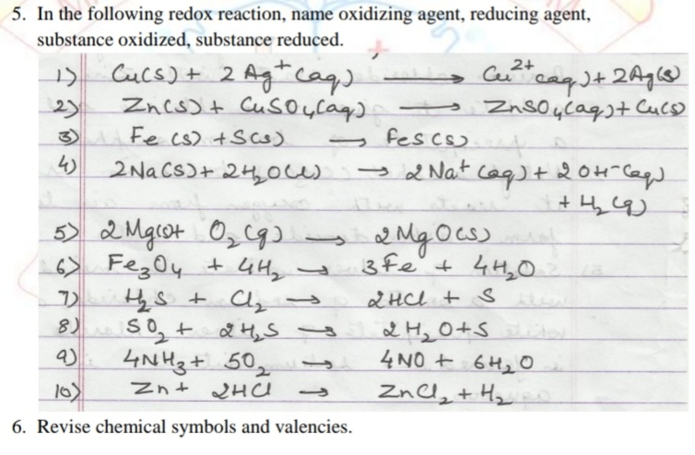
- 1. Write the chemical formula of the following compounds.
(i) Lime (ii) Nitric Acid (iii) Plaster of Paris (iv) Sodium acetate (v) Baking soda (vi) Washing soda (vii) Bleaching powder (viii) King of chemical (ix) Lime stone (x) Common Salt
2. Write the formula of acid and base used to form the given salts.
(i) Potassium Sulphate (ii) Zinc Chloride (iii) Ammonium Chloride (iv) Barium Sulphate.
3. Write the name of acid present in the following.
(i) Apple (ii) Curd (iii) Vinegar (iv) Lemon (v) Orange (vi) Bee sting (vii) Tamarind
4. Write the name of some (at least 10) chemical compounds that you use in your day to day life. Classify them as acids, bases and salts.

SUBJECT – MATHEMATICS
- Complete all the exercise in the fair copy.
SUBJECT – HINDI
iz- 1 ehjk ckbZ vkSj dchj nkl th ds in O;k[;k lfgr fyf[k,A
iz- 2 fgj.k dh ukfHk esa tks dLrwjh jgrh gS mlds ckjs esa tkudkjh izkIr djds fyf[k,A
iz- 3 gekjs ;gk¡ nl vorkj ekus tkrs gS tSls & jke] fo".kq] d`".k vkfn vU; vorkjksa ds ckjs esa tkudkjh izkIr djds fyf[k,A
iz- 4 D;k ijh{kk ikl dj ysuk gh ;ksX;rk dk vk/kkj gS bl fo"k; vius fopkj O;Dr dhft,A
iz- 5 vkidh NksVh cgu @ NksVk HkkbZ Nk=kokl esa jgrk @ jgrh gS mldh i<kbZ fy[kkbZ ds lEcU/k esa mls ,d i= fyf[k,A
iz- 6 vkt dh ih<+h ds fy, la;qDr ifjokj D;ksa t:jh gS fyf[k,A
iz- 7 dksjksuk ok;jl ij ,d ys[k fyf[k,A
iz- 8 20 ist lqUnj lqys[k fyf[k,A

